|  |  |  |  |
| --- | --- | --- | --- |
| **Course Name:** | **Elements of Electrical and Electronics Engineering** | **Semester:** | **II** |
| **Date of Performance:** | **29/02/ 2022** | **Batch No:** | **P1 - 2** |
| **Faculty Name:** |  | **Roll No:** | **16014022050** |
| **Faculty Sign & Date:** |  | **Grade/Marks:** | **/ 25** |

**Experiment No: 2**

**Title:** **Battery Voltage level Indicator.**

|  |
| --- |
| **Aim and Objective of the Experiment:** |
| * To understand voltage division concept, current division concept and principle of operation of LED. * To develop a micro project (Battery level indicator) based on the concepts learned in the form of various task performed in the experiment. |

|  |
| --- |
| **COs to be achieved:** |
| **CO1:** Analyze resistive networks excited by DC sources using various network theorems. |

|  |
| --- |
| **Circuit Diagram/ Block Diagram:** |
| **Task 1: Voltage division Concept and its verification on breadboard**    **Task 2**: **Current division Concept**    **Task Task 3: Turn on an LED and measure its turn-on voltage**    **Task 4: Battery Level Indicator Circuit** |

|  |
| --- |
| **Stepwise-Procedure:** |
| 1. Make the connections as shown in the circuit diagram for Task1. Measure the voltages Va, Vb  and current Is for Task 1 and compare with calculated results.  2. Make the connections as shown in the circuit diagram for Task2. Measure the currents I1,I2, I3  and IS and compare with calculated results.  3. Make the connections as shown in the circuit diagram for Task3. Measure the voltages VS, VD,  VR1 for Case1 and Case 2.  4. Make the connections as shown in the circuit diagram for Task4. Measure the voltages across  LED and resistors. |

|  |
| --- |
| **Observation Table:** |
| **Observation table 1 (Task 1):**   |  |  |  | | --- | --- | --- | | **Voltages / Currents** | **Theoretical reading (V)** | **Practical reading (V)** | | Va | 7.55 | 7.59 | | Vb | 4.53 | 4.51 | | Is | 1.37 mA | 1.38 mA |   Vs = 8.92V  **Theoretical –**  Vs = Is * RT  Is = = 1.37 mA  **Practical –**  Is = = 1.38 mA  **Calculations (Task1):**  Calculate Va and Vb using the formula given below:  **Observation table 2 (Task 2):**   |  |  | | --- | --- | | **Currents** | **Theoretical reading (mA)** | | I1 | 9.00 | | I2 | 4.02 | | I3 | 2.72 | | IS | 15.74 |   **Calculations (Task2):**  Calculate I1, I2, I3 and IS using the formula given below:  **Observation table 3 (Task 3):**  Case 1: LED just turn’s ON   |  |  | | --- | --- | | **Parameters** | **Practical reading (V)** | | VS | 1.90 | | VD | 1.72 | | VR1 | 0.20 |   Case 2: LED turn’s ON (glows brightly)   |  |  | | --- | --- | | **Parameters** | **Practical reading (V)** | | VS | 9.00 | | VD | 1.72 | | VR1 | 7.10 |   **Observation table 4 (Task4):**  Case 1: Supply voltage levels recording   |  |  | | --- | --- | | **Scenario** | **DC Supply voltage (VS) reading** | | LED 1 ON | 2.50 | | LED 1 ON & LED 2 ON | 4.20 | | LED 1 ON & LED 2 ON &  LED 3 ON | 6.00 | | ALL LEDs ON | 8.10 |   **Case**  Case 2: Status of voltages in the circuit   |  |  | | --- | --- | | **Voltages** | **Practical reading (V)** | | VLED 1 | 2.01 | | VLED 2 | 1.95 | | VLED 3 | 1.91 | | VLED 4 | 1.82 | | VR1 | 7.06 | | VR2 | 5.10 | | VR3 | 3.14 | | VR4 | 1.31 |   **Screenshot of Output:** |

|  |
| --- |
| **Post lab subjective/objective type questions:** |
| 1. **Mention some applications of battery level indicator.**   Battery level indicator is the project that indicates status of battery by use of LED and LCD. This project can know the status of battery left. This is can give easier to people and can be more alert then about status of battery level. The battery level indicator is shown in dot or bar form in mobile phones. This can easily recognize the battery level. Battery level indicator can present a circuit that can know the battery level of a device from the number of LED glowing and display on LCD.   1. **Explain practical usage of Voltage- division concept?**   Voltage dividers are used for adjusting the level of a signal, for bias of active devices in amplifiers, and for measurement of voltages. A [Wheatstone bridge](https://en.wikipedia.org/wiki/Wheatstone_bridge) and a [multimeter](https://en.wikipedia.org/wiki/Multimeter) both include voltage dividers. A [potentiometer](https://en.wikipedia.org/wiki/Potentiometer) is used as a variable voltage divider in the volume control of many radios. Sensor measurement - Voltage dividers can be used to allow a microcontroller to measure the resistance of a sensor.High voltage measurement - A voltage divider can be used to scale down a very [high voltage](https://en.wikipedia.org/wiki/High_voltage) so that it can be measured by a [volt meter](https://en.wikipedia.org/wiki/Volt_meter).Logic level shifting - A voltage divider can be used as a crude [logic level shifter](https://en.wikipedia.org/wiki/Logic_level_shifter) to interface two circuits that use different operating voltages.  1. **Explain working of Battery Level Indicator implemented in this experiment in your own words?**   This experiment mimics many uses of the battery level indicator in old phones and nowadays in power banks. As the voltage/power increases the indicators brighten up to show the strength or charge of the particular object. Similarly, in this experiment we see that as the voltage from the DC supply is increased the bulbs start to glow one by one. Each bulb indicates a percentage of charge or unit that the voltage has risen too. Once the last bulb starts to glow the circuit (or object) has reached maximum voltage (or charge/power). This is how we see the working of a Battery Level Indicator using this experiment. |

|  |
| --- |
| **Conclusion:** |
| Using this experiment, we are able to clear our concepts of voltage division concept, current division concept and principle of operation of LED. Moreover, the mini project greatly develops are understanding of a battery level indicator and its function. |

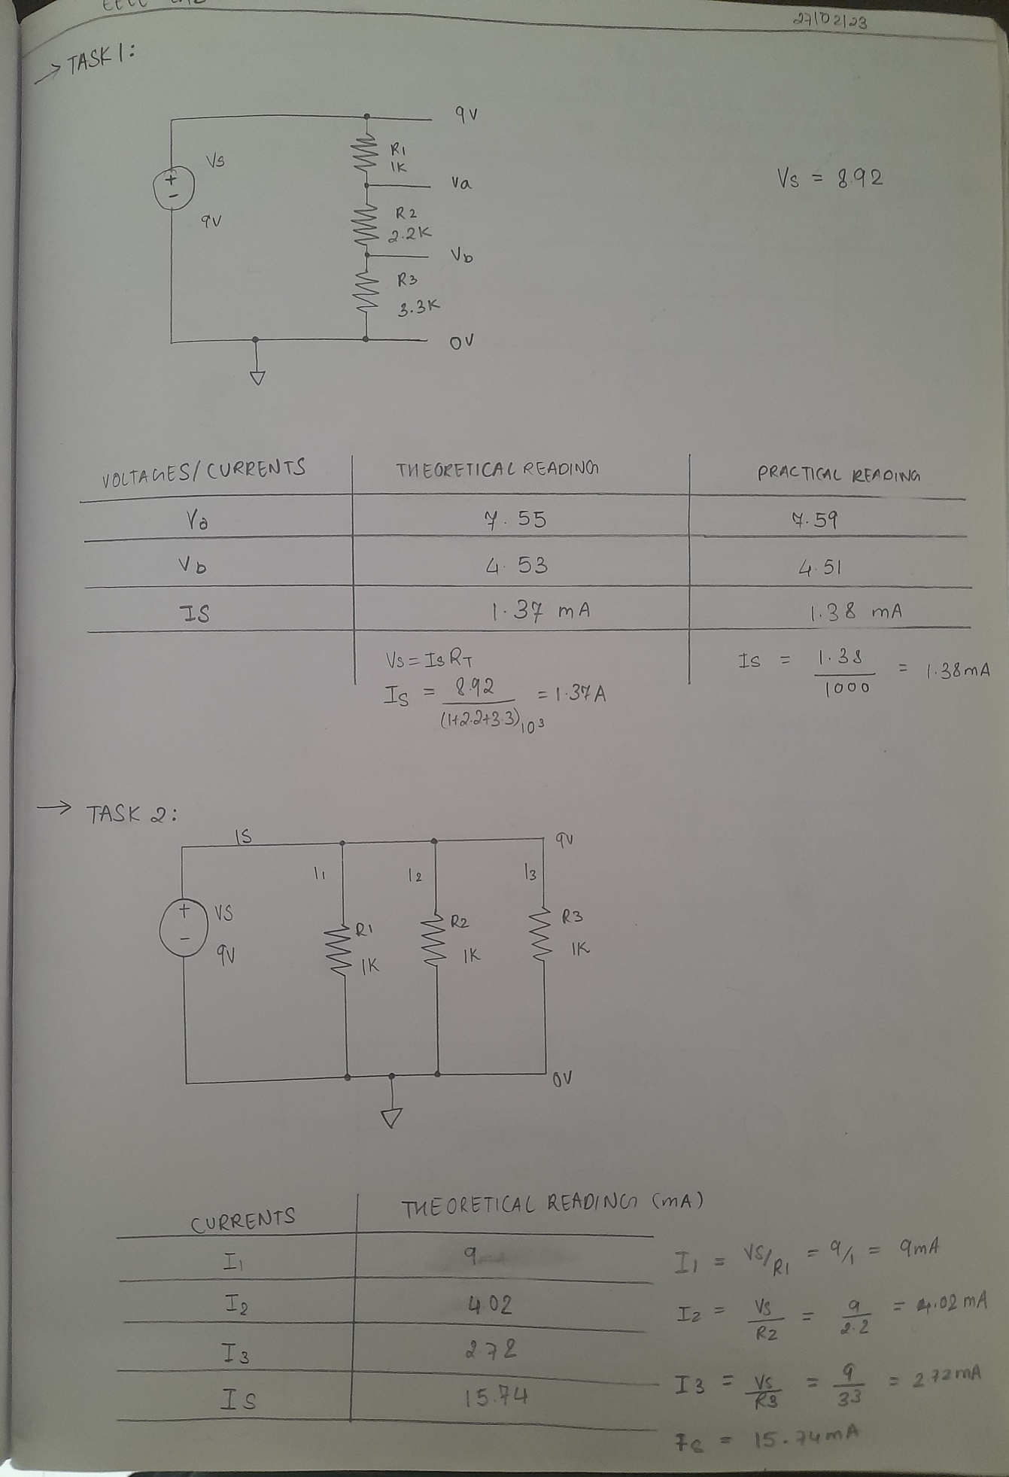

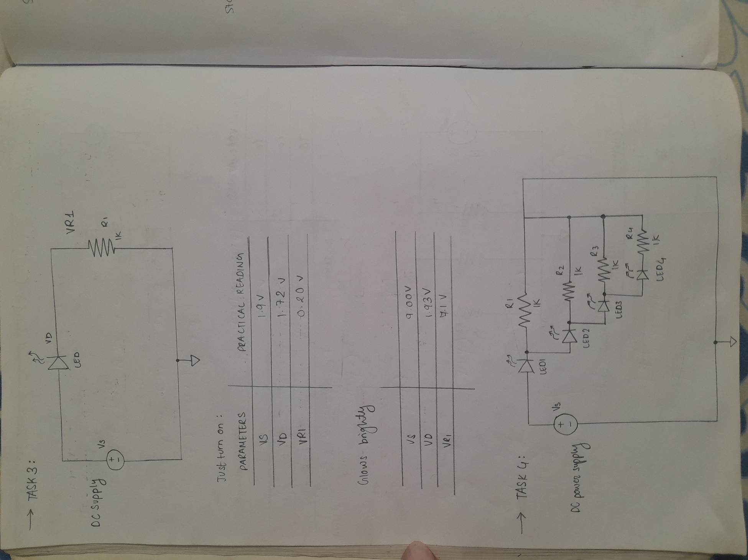

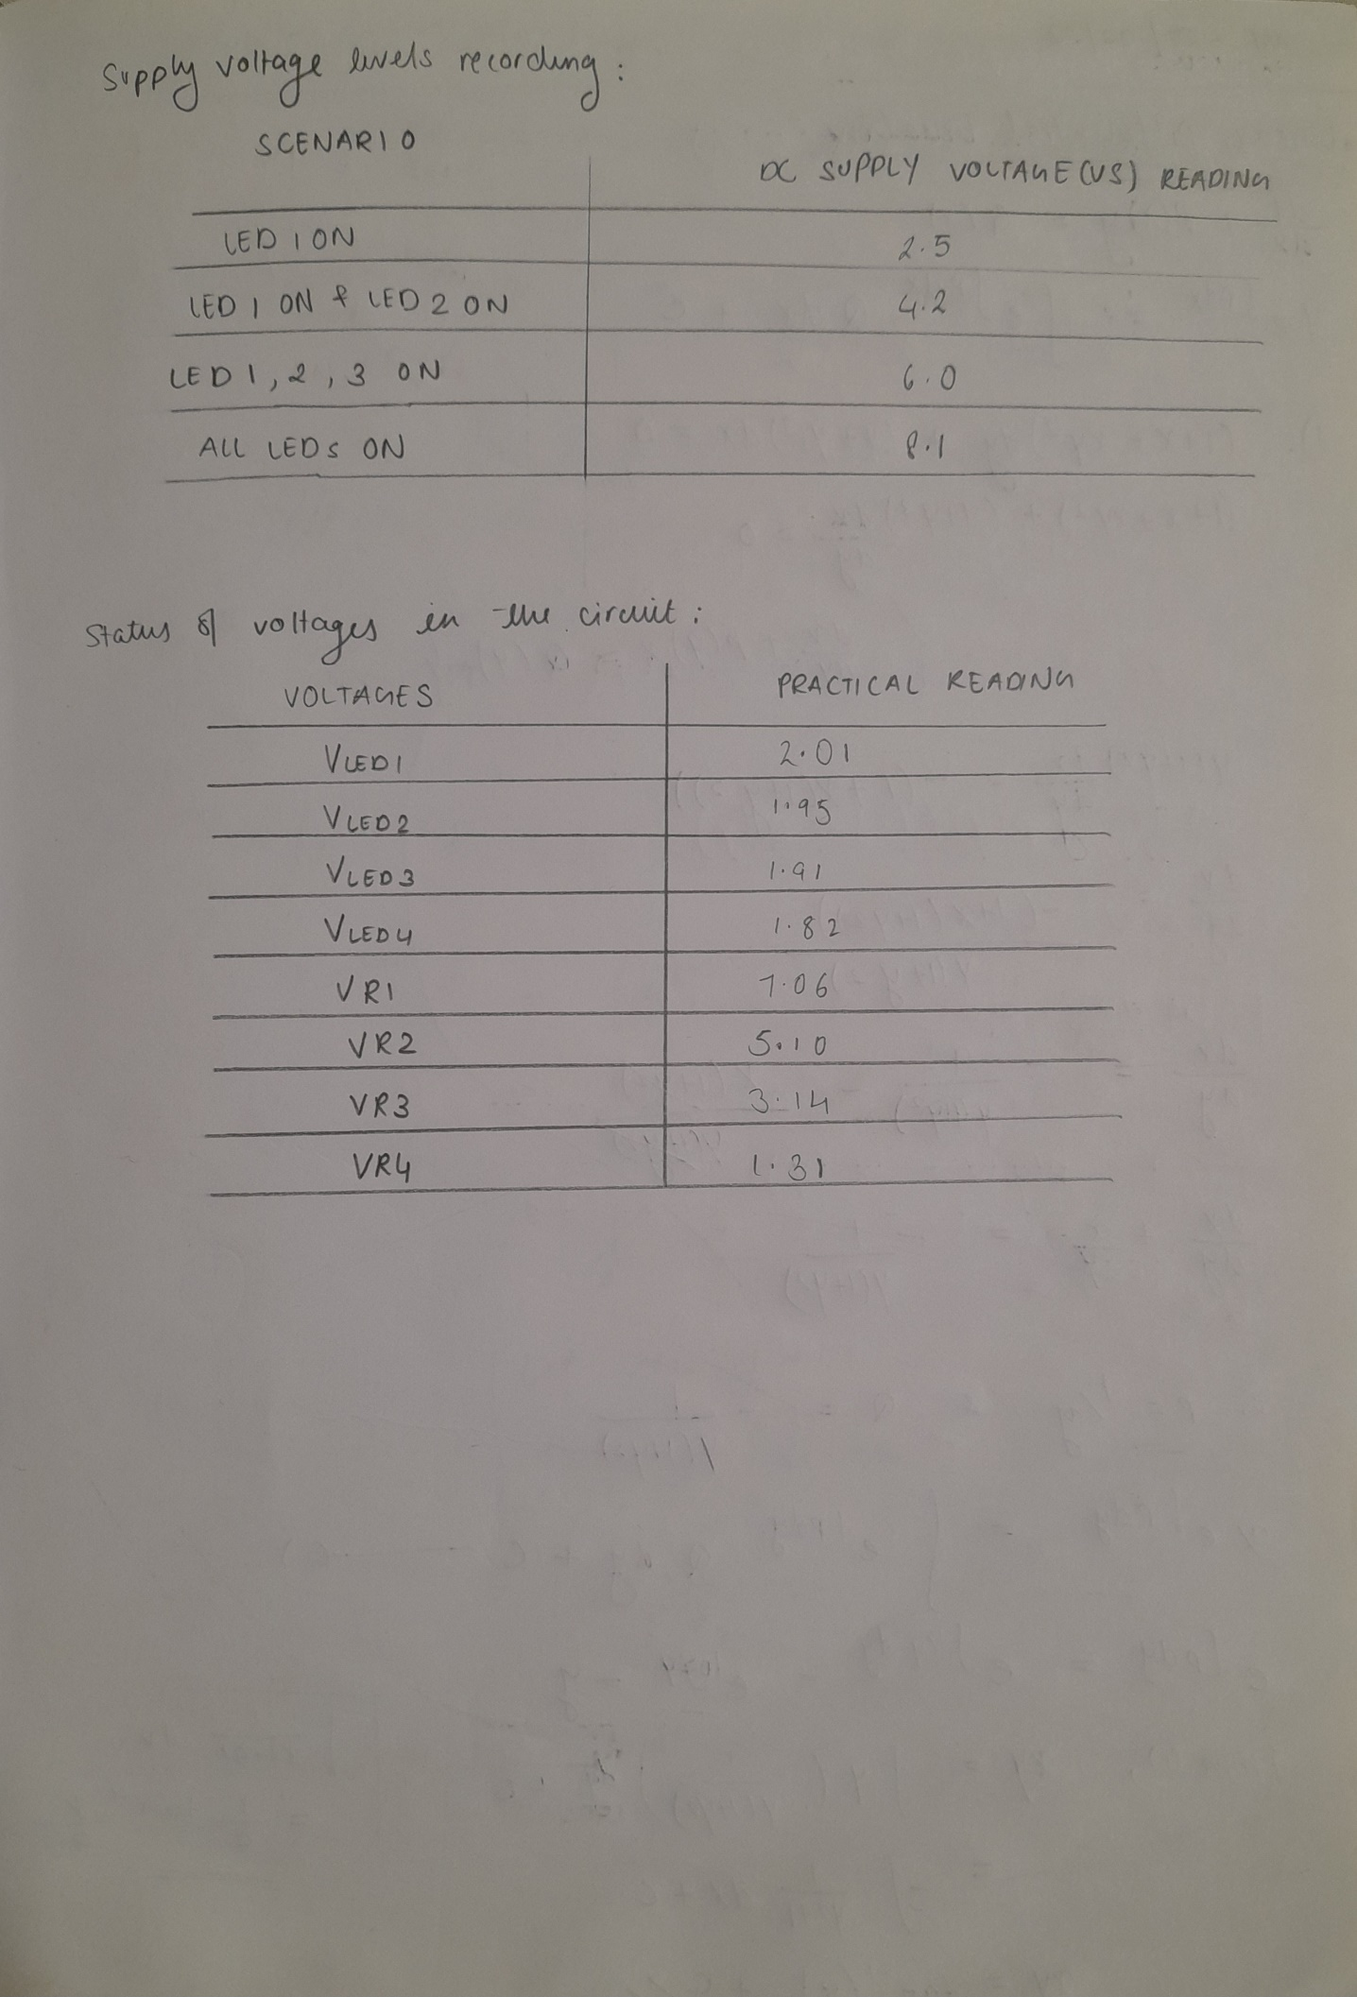

**Signature of faculty in-charge with Date:**